**Laporan Praktikum**

**Pemrograman Web 1**

**Dosen pengampu : Yati Nurhayati S.Kom., M.Kom**



**Nama : Bayu Imantoro**

**NIM : 20230810089**

**Kelas : TINFC – 2023 – 04**

**Teknik Informatika**

**Fakultas Ilmu Komputer**

**Universitas Kuningan**

PRAKTIKUM

1. M6-1

<!DOCTYPE html>

<html lang = "id">

<head>

<meta charset = "UTF-8" />

<meta name = "viewport" content = "width=device-width", initial-scale = 1.0>

<title>JQuery</title>

<script src = "jquery-3.7.1.js"></script>

<script>

$(document).ready(function(){

$(".tampil").hide();

$(".sembunyi").click(function(){

$(".uniku").hide("slow");

$(".tampil").show();

$(".sembunyi").hide();

});

$(".tampil").click(function(){

$(".uniku").show("slow");

$(".tampil").hide();

$(".sembunyi").show();

});

});

</script>

</head>

<body>

<button class = "sembunyi">Hide</button>

<button class = "tampil">Show</button>

<div class = "uniku">Universitas Kuningan</div>

</body>

</html>



1. M6-2

<!DOCTYPE html>

<html lang = "id">

<head>

<meta charset = "UTF-8" />

<meta name = "viewport" content = "width=device-width", initial-scale = 1.0>

<title>JQuery</title>

<script src = "jquery-3.7.1.js"></script>

<script>

$(document).ready(function(){

$(".fadeout").click(function(){

$("img").fadeOut();

});

$(".fadein").click(function(){

$("img").fadeIn();

});

$(".fadetoogle").click(function(){

$("img").fadeToggle();

$("img").css("background-color", "orange");

});

$(".fadeto").click(function(){

$("img").fadeTo("slow", 0.5);

$("img").css("background-color", "light-pink");

});

});

</script>

</head>

<body>

<button class = "fadeout" style = "background-color : #add8e6;">Fade Out</button>

<button class = "fadein" style = "background-color : #00bfff;">Fade In</button>

<button class = "fadetoggle" style = "background-color : #ffa500;">Fade Toggle</button>

<button class = "fadeto" style = "background-color : #ffb6c1;">Fade To</button>

<br/>

<img src = "https://th.bing.com/th/id/OIP.LWVwJY4gfS7oVBdnVQauAQHaHa?rs=1&pid=ImgDetMain" width = "300" height = "300"/>

</body>

</html>



1. M6-3

<!DOCTYPE html>

<html lang = "id">

<head>

<meta charset = "UTF-8" />

<meta name = "viewport" content = "width=device-width", initial-scale = 1.0>

<title>JQuery</title>

<script src = "jquery-3.7.1.js"></script>

<style>

.tab{

display : none;

}

.tab-button{

background-color : #f1f1f1;

cursor : pointer;

padding : 10px;

border : 1px solid #ccc;

display : inline-block;

}

.active{

background-color : #ccc;

}

</style>

</head>

<body>

<h1>Tugas Web Developer</h1>

<div>

<div class = "tab-button active" data-tab = "tab1">Tab 1</div>

<div class = "tab-button" data-tab = "tab2">Tab 2</div>

<div class = "tab-button" data-tab = "tab3">Tab 3</div>

</div>

<div id = "tab1" class = "tab" style = "display : block">

<h2>Front-End Developer</h2>

<p>Mengoptimalkan Fungsi Aplikasi berdasarkan User Interface (UI)

dan User Experience (UX).</p>

</p>

</div>

<div id = "tab2" class = "tab">

<h2>Back-End Development</h2>

<p>Berjalan di Sisi Server dengan Mengelola Data menjadi

Informasi dari Database.

</p>

</div>

<div id = "tab3" class = "tab">

<h2>Full-Stack Development</h2>

<p>Memiliki Kemampuan di Kedua Sisi yaitu, Front-End dan Back-End, Sehingga Dapat

Menangani Semua Aspek Pengembangan Web.

</p>

</div>

<script>

$(document).ready(function(){

$(".tab-button").click(function(){

$(".tab").hide();

$(".tab-button").removeClass("active");

tabToShow = $(this).data("tab");

$("#" + tabToShow).show();

$(this).addClass("active");

});

});

</script>

</body>

</html>

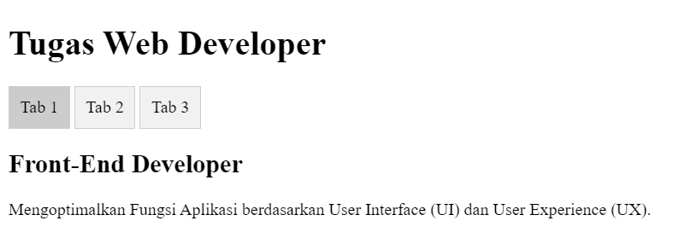

1. M6-4

<!DOCTYPE html>

<html lang = "id">

<head>

<meta charset = "UTF-8" />

<meta name = "viewport" content = "width=device-width", initial-scale = 1.0>

<title>Pie Chart dan Bar Chart</title>

<script src = "jquery-3.7.1.js"></script>

<script src = "chart.js"></script>

</head>

<body>

<h1>Data Tingkat Pendidikan Masyarakat (dalam %)</h1>

<h2>Tahun 2024</h2>

<canvas id = "myPieChart"></canvas>

<script>

$(document).ready(function(){

pieData = {

labels : ["SD", "SMP", "SMA"],

datasets : [

{

data : [50, 30, 20],

backgroundColor : ["#ff6384", "#36a2eb", "#ffce56"]

}

]

}

ctxPie = document.getElementById("myPieChart").getContext("2d");

myPieChart = new Chart(ctxPie, {

type : "pie",

data : pieData,

});

});

</script>

</body>

</html>



1. M5-5

<!DOCTYPE html>

<html lang = "id">

<head>

<meta charset = "UTF-8" />

<meta name = "viewport" content = "width=device-width", initial-scale = 1.0>

<title>Akses Kamera dengan JQuery</title>

<script src = "jquery-3.7.1.js"></script>

</head>

<body>

<h1>Menampilkan Video dari Kamera</h1>

<button id = "start">Mulai Kamera</button>

<button id = "stop">Hentikan Kamera</button>

<script>

$(document).ready(function(){

const video = document.createElement("video");

let mediaStream;

$("#start").click(function(){

navigator.mediaDevices

.getUserMedia({video: true})

.then(function(stream){

mediaStream = stream;

video.srcObject = stream;

})

.catch(function(err){

console.error("Gagal mengakses Kamera: " + err);

});

});

$("#stop").click(function(){

if(mediaStream){

mediaStream.getTracks().forEach((track) => track.stop());

video.srcObject = null;

}

});

});

</script>

</body>

</html>

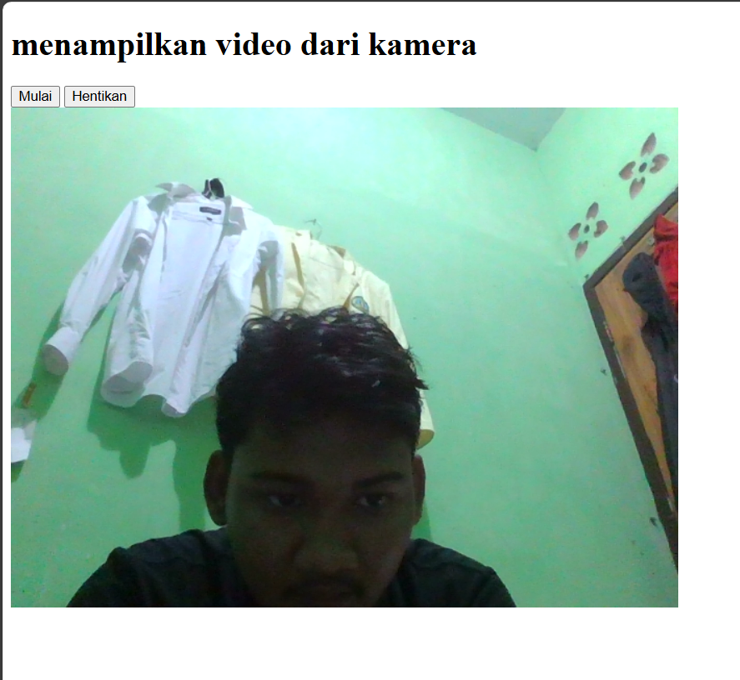

1. M6-6

<!DOCTYPE html>

<html lang = "id">

<head>

<meta charset = "UTF-8" />

<meta name = "viewport" content = "width=device-width, initial-scale = 1.0">

<title>Manipulasi DOM dengan JQuery</title>

<script src = "jquery-3.7.1.js"></script>

</head>

<body>

<h1>Manipulasi DOM dengan JQuery</h1>

<button id = "tambah">Tambah Data</button>

<button id = "ubah">Ubah Data Pertama</button>

<button id = "hapus">Hapus Data Terakhir</button>

<div id = "output">

<div class = "item">Data 1</div>

<div class = "item">Data 2</div>

<div class = "item">Data 3</div>

</div>

<script>

$(document).ready(function(){

$("#tambah").on("click", function(){

$("#output").append('<div class = "item">Data Baru</div>');

});

$("#ubah").on("click", function(){

$("#output .item:first").text("Data Pertama Diubah");

});

$("#hapus").on("click", function(){

$("#output .item:last").remove();

});

});

</script>

</body>

</html>

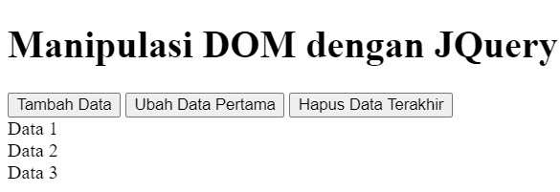

1. M6-7

<!DOCTYPE html>

<html lang = "id">

<head>

<meta charset = "UTF-8" />

<meta name = "viewport" content = "width=device-width, initial-scale = 1.0">

<title>Penerapan Event Handling dengan JQuery</title>

<script src = "jquery-3.7.1.js"></script>

<style>

body {

font-family: Arial, sans-serif;

margin : 20px;

}

.box {

width : 100px;

height : 100px;

background-color : lightblue;

display : inline-block;

text-align : center;

line-height : 100px;

font-weight : bold;

cursor : pointer;

transition : background-color 0.3s;

}

</style>

</head>

<body>

<h1>Penerapan Event Handling dengan JQuery</h1>

<div class = "box" id = "box1">Box 1</div>

<div class = "box" id = "box2">Box 2</div>

<div class = "box" id = "box3">Box 3</div>

<script>

$(document).ready(function(){

$(".box").on("click", function(){

$(this).toggleClass("active");

alert('Anda mengklik ${$(this).text()}');

});

$(".box").on("mouseenter", function(){

$(this).css("background-color", "lightgreen");

});

$(".box").on("mouseleave", function(){

$(this).css("background-color", "lightblue");

});

});

</script>

</body>

</html>

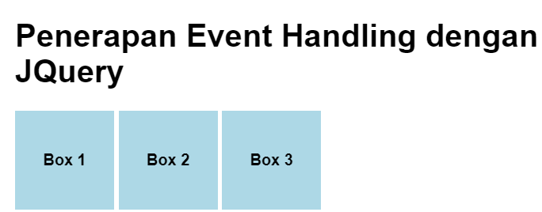

TUGAS

1. Perhitungan.html

<!DOCTYPE html>

<html lang="en">

<head>

<meta charset="UTF-8">

<meta name="viewport" content="width=device-width, initial-scale=1.0">

<title>Form Pemesanan</title>

<link rel="stylesheet" href="styles1.css">

<script src="../praktikum/js/jquery-3.7.1.min.js"></script>

</head>

<body>

<div class="container">

<h2>Form Pemesanan</h2>

<form id="formPemesanan">

<table>

<tr>

<td>Nama Pemesan:</td>

<td><input type="text" id="namaPemesan" name="namaPemesan" placeholder="Masukan Nama" required></td>

</tr>

<tr>

<td>Jenis Kelamin:</td>

<td>

<label>

<input type="radio" id="jenisKelaminL" name="jenisKelamin" value="Laki-laki"> Laki-laki

</label>

<label>

<input type="radio" id="jenisKelaminP" name="jenisKelamin" value="Perempuan"> Perempuan

</label>

</td>

</tr>

<tr>

<td>Nomor Identitas:</td>

<td><input type="text" id="nomorIdentitas" name="nomorIdentitas" maxlength="16" placeholder="Masukkan Nomor Identitas" required></td>

</tr>

<tr>

<td>Tipe Kamar:</td>

<td>

<select id="tipeKamar" name="tipeKamar" required>

<option value="">--Pilih--</option>

<option value="standar" data-harga="500000">Standar</option>

<option value="deluxe" data-harga="800000">Deluxe</option>

<option value="family" data-harga="1200000">Family</option>

</select>

</td>

</tr>

<tr>

<td>Harga:</td>

<td><input type="text" id="harga" name="harga" placeholder="Otomatis" readonly></td>

</tr>

<tr>

<td>Tanggal Pesan:</td>

<td><input type="date" id="tanggalPesan" name="tanggalPesan" required></td>

</tr>

<tr>

<td>Durasi Menginap:</td>

<td><input type="number" id="durasiMenginap" name="durasiMenginap" min="1" placeholder="Masukkan Durasi Menginap" required></td>

<td>Hari</td>

</tr>

<tr>

<td>Termasuk Breakfast:</td>

<td><input type="checkbox" id="termasukBreakfast" name="termasukBreakfast"> Ya</td>

</tr>

<tr>

<td>Total Bayar:</td>

<td><input type="text" id="totalBayar" name="totalBayar" placeholder="Otomatis" readonly></td>

</tr>

</table>

<div class="buttons">

<button type="button" class="save">Simpan</button>

<button type="reset" class="cancel">Batal</button>

</div>

</form>

<!-- div untuk menampilkan struk -->

<div id="strukOutput" style="margin-top: 20px; border: 1px solid #ff0000; padding: 10px; display: none;"></div>

</div>

<script>

$(document).ready(function () {

//otomatis masukkan harga ke input harga saat tipe kamar dipilih,

$("#tipeKamar").change(function () {

const hargaKamar = $(this).find(":selected").data("harga") || 0;

$("#harga").val(`Rp ${hargaKamar.toLocaleString("id-ID")}`);

});

$("#formPemesanan .save").click(function () {

const namaPemesan = $("#namaPemesan").val();

const jenisKelamin = $('input[name="jenisKelamin"]:checked').val();

const nomorIdentitas = $("#nomorIdentitas").val();

const tipeKamar = $("#tipeKamar option:selected").text();

const hargaKamar = $("#tipeKamar").find(":selected").data("harga") || 0;

const durasiMenginap = parseInt($("#durasiMenginap").val());

const termasukBreakfast = $("#termasukBreakfast").is(":checked");

if (!namaPemesan || !jenisKelamin || !nomorIdentitas || !tipeKamar || durasiMenginap <= 0 || nomorIdentitas.length < 16) {

alert("Harap isi semua data dengan benar!");

return;

}

//menghitung total biaya

let total = hargaKamar * durasiMenginap;

let diskon = 0;

//tambah diskon 10% jika menginap lebih dari 3 hari

if (durasiMenginap > 3) {

diskon = total * 0.1;

total -= diskon;

}

//tambahan biaya breakfast jika dipilih

if (termasukBreakfast) {

total += 80000;

}

//total bayar

$("#totalBayar").val(`Rp ${total.toLocaleString("id-ID")}`);

//menampilkan struk

const struk = `

<h3>STRUK PEMESANAN</h3>

<p>Nama Pemesan : ${namaPemesan}</p>

<p>Jenis Kelamin : ${jenisKelamin}</p>

<p>Nomor Identitas : ${nomorIdentitas}</p>

<p>Tipe Kamar : ${tipeKamar}</p>

<p>Durasi Menginap : ${durasiMenginap} Hari</p>

<p>Diskon : Rp ${diskon.toLocaleString("id-ID")}</p>

<p>Total Bayar : Rp ${total.toLocaleString("id-ID")}</p>

`;

$("#strukOutput").html(struk).show();

});

$(".cancel").click(function () {

$("#strukOutput").hide().html("");

});

});

</script>

</body>

</html>

Styles1.css

* {

    box-sizing: border-box;

}

body {

    font-family: Arial, sans-serif;

    background-image: url('https://th.bing.com/th/id/OIP.n5AfiSWTJ9o-qzaLQ3NySwHaJQ?w=960&h=1200&rs=1&pid=ImgDetMain');

    background-size: cover;

    background-position: center;

    display: flex;

    justify-content: center;

    align-items: center;

    height: 100vh;

    margin: 0;

}

.container {

    width: 500px;

    padding: 20px;

    background-color: #ffffff41;

    backdrop-filter: blur(5px);

    box-shadow: 0px 0px 15px rgba(0, 0, 0, 0.5);

    border-radius: 8px;

}

h2 {

    text-align: left;

    color: #333;

}

form {

    display: flex;

    flex-direction: column;

}

table {

    width: 100%;

    border-collapse: collapse;

    margin-bottom: 20px;

}

td {

    padding: 4px;

    color: #333;

    vertical-align: middle;

}

input[type="text"],

input[type="number"],

input[type="date"],

select {

    background-color: #ffffff1a;

    backdrop-filter: blur(5px);

    padding: 8px;

    border: 1px solid #cccccc;

    border-radius: 4px;

    width: 100%;

}

input[type="checkbox"] {

    margin-left: 0;

}

.buttons {

    display: flex;

    justify-content: space-evenly;

}

button {

    padding: 10px 20px;

    border: none;

    border-radius: 4px;

    color: #fff;

    cursor: pointer;

}

button.save {

    background-color: rgb(0, 123, 255);

    box-shadow: 0px 0px 8px rgb(0, 60, 255);

}

button.cancel {

    background-color: #ffc107;

    box-shadow: 0px 0px 8px rgb(255, 174, 0);

}

